### SADC Remuneration Commissions Conference - *30 November 2012*

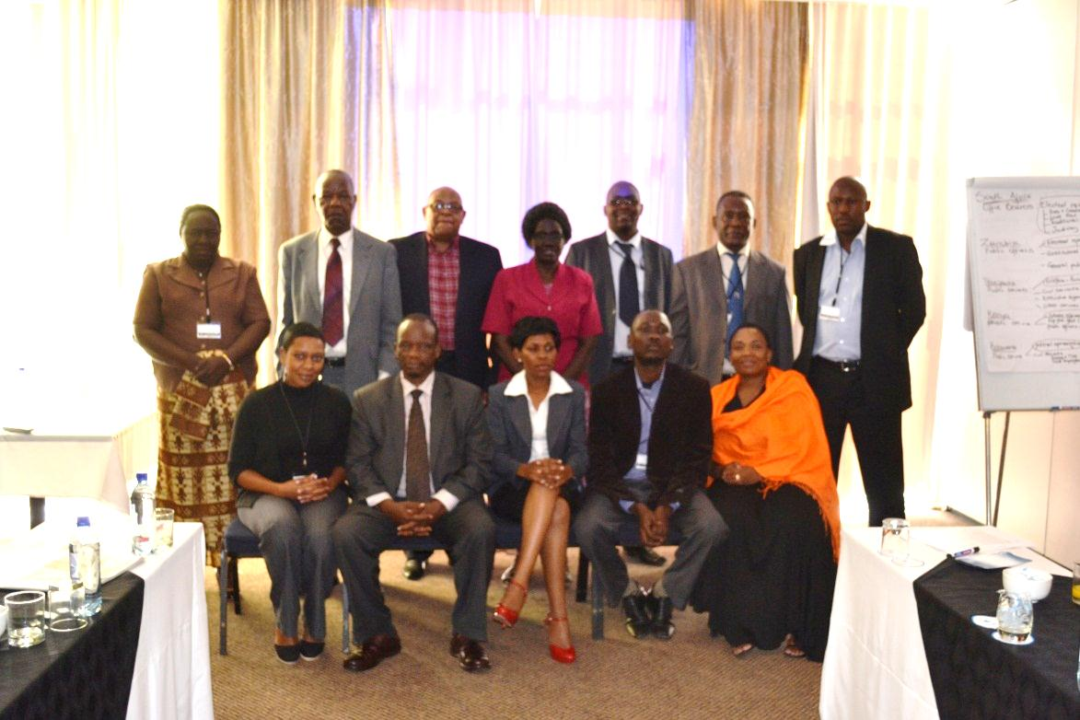

### 1. Introduction

During December 2010 the Independent Commission for the Remuneration of Public Office Bearers (RSA Commission) convened a SADC conference were representatives from South Africa, Kenya, Zimbabwe, Malawi and Namibia attended. During the conference it was agreed that the next conference be extended to other countries and rotate between the countries for hosting. Namibia was considered as the next country to host the conference.

The Public Office Bearers Remuneration & Benefit Commission (Namibian Commission) and the RSA Commission’s Secretariat jointly convened the second SADC Remuneration Conference. The conference was held at the Seaside Hotel and Spa in Swakopmund on 28 – 30 November 2012.

Representatives from South Africa, Namibia, Zambia, Kenya, Botswana and Tanzania attended and participated during the conference. The theme for the conference was ‘Balanced remuneration determination with the call for outstanding service delivery to the citizens’.

The Namibian Commissioner, Mr. Marc Nel, did the welcoming and opening remarks on behalf of the Namibian Commission Chairperson, Judge President Peter T Damaseb, and the Head of RSA Commission Secretariat, Mr PM Makapan, facilitated the proceedings of the conference.

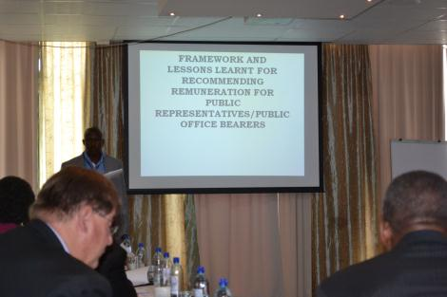

### 2. Objectives

The objective of the conference was to share best practices on remuneration determinations and to formulate clear relations of the Commissions/Tribunals. This also presented an important opportunity to share lessons learned on how public office-bearer remuneration is managed and rewarded.

### 3. Presentation and discussion

The following presentations were made during the Conference:

* Universal role of Commissions/Tribunals in determining the remuneration of public representatives and benefit for countries to entrench this role in the Constitution
* Framework and lessons learned for recommending remuneration for public representatives
* Measures to ensure equitable remuneration for public representatives against government budget
* Performance based remuneration for public representatives – (open discussion)
* Communication strategy on determination of public representatives remuneration – (open discussion)
* Lessons learned on governance within the Commission(s)/Tribunal(s) – (open discussion)
* Development of Commission’s/Tribunal’s relations charter and a way forward

### 4. Universal role of Commissions / Tribunals in determining the

### remuneration of public representatives and benefit for countries to entrench this role in the Constitution

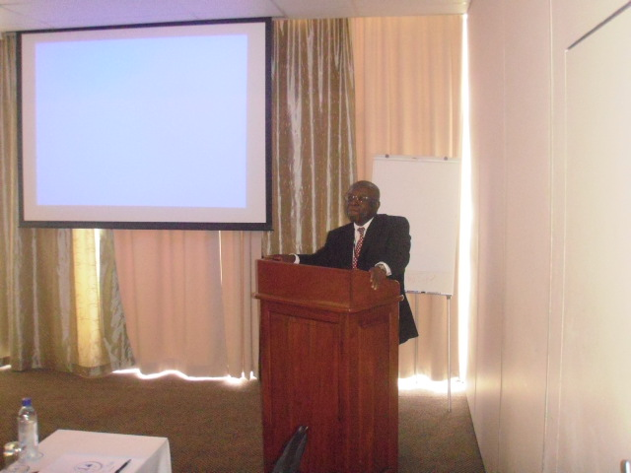

The Chairperson of RSA Commission, Judge WL Seriti, made presentation on the above topic that covered amongst others the following:

* Public and media interest on the remuneration of public office-bearers
* A need for establishment of independent statutory bodies to ensure transparency in the remuneration of public office bearers
* Constitutional imperatives to establish remuneration Commissions for public office bearers (POBs)
* The legislative framework of the RSA Commission and a draft Bill that will extend the mandate of the RSA Commission to determine remuneration of the Constitutional Institutions (Section 219 of RSA Constitution, Independent Commission for Remuneration of POB Act 92 of 1997 and Remuneration of POB Act 20 of 1998)
* The RSA Commission review process since March 2007 to date
* Lessons learned in recommending remuneration of public office-bearers in RSA

### 5. Measures to ensure equitable remuneration for public representatives /

### public office bearers against government budget

The Deputy Minister of Finance, Hon C Schlettwein, presented a paper on the above topic and covered amongst others the following:

* Fiscal metrics for affordability and equitable remuneration: the size of government as measured by public sector contribution to GDP and share of total employment, and government compensation of employees as illustrated by remuneration as a share of GDP, domestic revenues and per capita incomes
* The case of education and health spending
* Per Capita equivalents and cost of living indexing
* Towards an equitable public service remuneration structure for Namibia

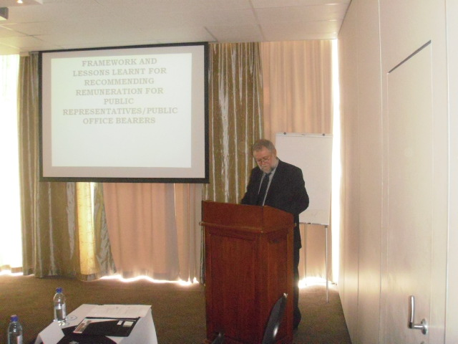

### 5.1. Framework and lessons learnt for recommending remuneration for public

### representatives /public office bearers

The conveners of the conference requested each participating country to prepare a presentation on the above topic in relation to their countries’ practices and lessons learned. The following countries made insight presentations as follows:

### 5.1.1 Salaries and Remuneration Commission of Kenya

Mrs Grace Otieno, Commission Secretary and Chief Executive presented a paper on above topic that covers amongst the following:

* The establishment of the Kenyan Commission in terms of Chapter 12 Article 230(1) of the Constitution of Kenya, 2012
* Mandate, functions and powers of the Commission
* Pay setting and remuneration framework
* Constitutional provision and challenges
* Drafting regulations for submission of proposals and determining and advising on remuneration and benefits
* Markey surveys to establish data, job evaluation exercise, benchmark visits
* Harmonizing and restoring equity in remuneration cycle
* Database for review/determination of remuneration level
* Corporate governance
* Lessons learned are as follows: a need to have policy and legislations of addressing issues for remuneration and benefits; capacity building in particular research; development of strategic plan; and advocacy and communication

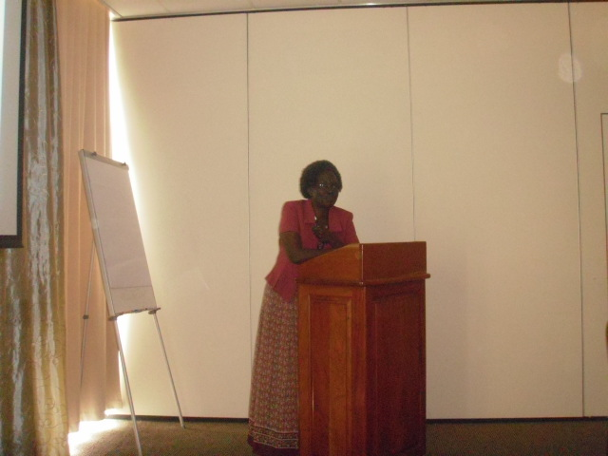

### 5.1. 2. Public Service Commission of Zambia

Mr. Felix Mushabati, Chief Human Resources Management Officer presented a paper on above topic that covered amongst others the following:

* Legal framework for determining remuneration for POBs, like Presidential Emoluments act
* Pay reforms, like rationalizing and harmonizing remuneration across all public service bodies
* Success stories: consolidation of remunerative salaries into basic salary which enhances real pay and pension benefits
* General challenges: no uniform definition of public office bearers
* Regional remuneration framework to reduce attrition
* Suggestion: to have a remuneration body with enabling legislation to determine and regulate remuneration

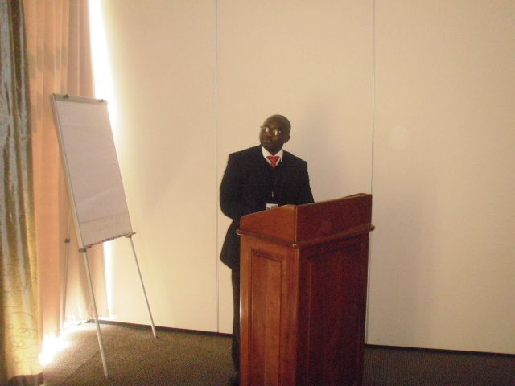

### 5.2. Open discussions

Presentations and discussion papers were circulated beforehand to facilitate discussions during the meeting.

### 5.2.1 Performance based remuneration for public representatives/public office

### bearers

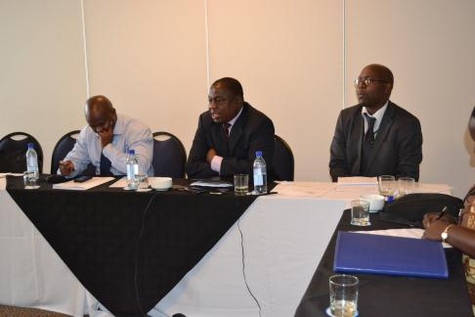

Dr. K Kamanga, Chairperson of Public Service Commission – Zambia, presented a paper on above topic that covered amongst others the following:

* Overview of performance based remuneration system: definitions
* The man objectives for the introduction of a performance based rewards systems
* Key elements of a performance based remuneration system to succeed
* Advantage and challenges of the performance based remuneration system

### 6. Communication Strategy on determination for public representatives/public

### officer bearers’ remuneration

Mr. Isaiah Kubai, Commissioner – Kenyan Salaries and Remuneration Commission, presented a paper on above topic that covers amongst the following:

* The need for a communication strategy (a need to explain and publicize roles of Commissions/Tribunals)
* Who will drive a communication strategy?
* To link the strategy to the mandate
* Identification of the audience/target
* Communication channels
* Communication frequency/timing and communicating “bad” news
* Language usage and message to be conveyed
* A need for communication philosophy of Commission/Tribunal to be in place
* Principles governing communication are essential like, transparency/access to information

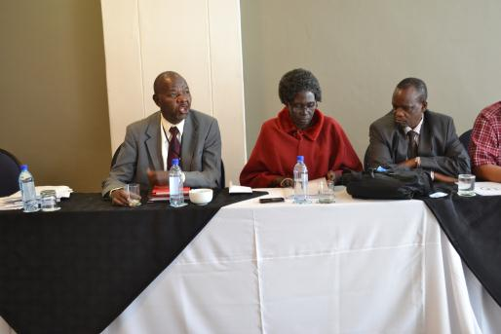

### 7. Lessons learnt on governance within the Commissions/Tribunals

Mr. Vincent Mrisho, Chairperson of Public Service Remuneration Board - Tanzania, presented a paper on above topic that covered amongst others the following:

* Wide range of definitions of governance from different scholars
* Some characteristics of good governance that includes the following: participation, transparency, responsiveness, consensus, rule of law, equity, accountability, efficiency and effectiveness
* Remuneration as a tool for good governance and challenges

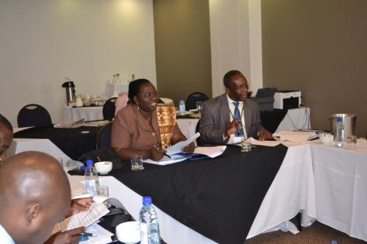

The conference identified following matters as important to work on:

* Conditions of appointing members
* Integrity of members of Commission/Tribunals
* Operational mandate that govern Commission, like scheduling of meetings, attendance
* Relationship of members with stakeholders
* Relationship of members with operational employees
* Ethical conduct of members
* Formulation of a governance charter
* Not to overpromise (if unable to deliver, not true to mandate)
* Monitor conflict through statute

### 8. Development of Commissions/Tribunals relations charter and a way forward

Adv. Neo Sephoti presented a draft Commissions/Tribunal Charter for consideration. The objectives of the Charter are as follows:

* Ensure avenues for capacity building of remuneration committees and their support structures with the view to improving quality of work of remuneration committees in Africa
* Facilitate, through close and active consultations among remuneration commissions, the establishment and promotion of good remuneration policies, practices and measures, which will allow the commissions to be effective and efficient in their roles in executing the mandate entrusted to them
* Provide a framework for regional co-operation in the collection and dissemination of remuneration information
* Promote the establishment and harmonisation of data storage banks to preserve institutional memory;
* Promote the development of institutional capacities, in both research and technical skills for the Commissions

The Charter was adopted by South Africa, Zambia, Tanzania, Botswana and Namibia. Kenya will endorse the Charter after their engagement and consultation at home with their counterparts.

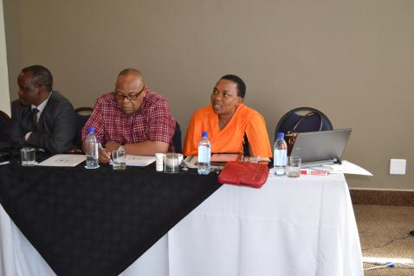

### 9. Way Forward

* The conference discussed the matter and agreed that the performance based remuneration for public office-bearers is not easy to implement and that more research need to be done on this topic.
* Countries agreed to prepare a paper based on topic and to share it with each country’s Secretariat. (Final doc to be channeled through their Secretariat).
* The conference agreed that Commissions should consider outsourcing its communication function for proper branding and establish its stakeholder matrix.
* The conference agreed to utilize the presentation as ‘good governance guide’.
* The conference agreed that all the participating countries should explore ways to host the next Conference excluding South Africa and Namibia. Countries should communicate their intension to host through respective Secretariats by 31 January 2013